DSA0602 – Activity: Redesign Misleading Color Charts
R.No: 4 | Reg. No: 192324305 | Name: AYESHA SIDDIQA S

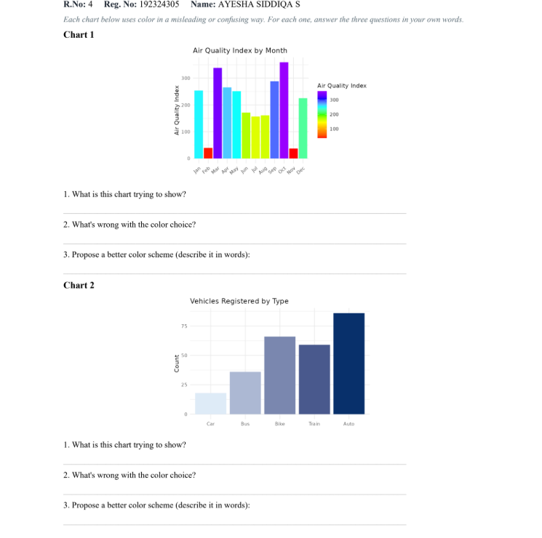
Chart 1: Air Quality Index by Month
1. What is this chart trying to show?
The chart shows the Air Quality Index (AQI) for each month from January to December. It helps compare air quality across months and identify months with higher or lower pollution levels.
2. What is wrong with the color choice?
The rainbow colour scheme uses too many different colours, making the chart confusing. The colours do not represent the AQI values clearly, and some colours may be difficult for colour-blind viewers to distinguish.
3. Propose a better colour scheme.
Use a sequential colour scale, such as light yellow to dark red, where lighter shades represent lower AQI and darker shades represent higher AQI. This makes the values easier to compare.
Chart 2: Vehicles Registered by Type
1. What is this chart trying to show?
The chart compares the number of vehicles registered across five categories: Car, Bus, Bike, Train and Auto.
2. What is wrong with the color choice?
The different shades of blue suggest a continuous numerical order among vehicle types. However, these are categorical groups, not values on a continuous scale. The colours do not clearly distinguish the categories.
3. Propose a better colour scheme.
Use a qualitative categorical colour palette, assigning a distinct colour to each vehicle type. Alternatively, use the same neutral colour for all bars and highlight only the category of interest.

